**🍽️ FoodieFoodie – Project Overview**

**📌 About the Project**

**FoodieFoodie** is a full-stack food blogging and recipe-sharing web application. It offers a platform for food enthusiasts to explore a variety of recipes, read food-related blogs, and contribute their own culinary creations. The system also includes an admin panel for content moderation, making it a complete and scalable content management solution for food lovers.

**🎯 Purpose**

The main objective of FoodieFoodie is to:

* Provide a community-driven platform for recipe sharing.
* Allow users to engage with food blogs and cooking ideas.
* Enable aspiring chefs and home cooks to showcase their dishes.
* Give admins control over published content through a secure dashboard.

**⚙️ Core Components**

**🔹 User System**

* Registration & Login
* Profile view
* Recipe submission
* View & search blogs and recipes

**🔹 Recipe System**

* Add, view, and explore recipes
* Display ingredients, method, and images
* Categorized listings (e.g., breakfast, lunch, snacks)

**🔹 Blog Module**

* Browse and read food-related blogs
* Blog detail pages with images and formatting

**🔹 Search Feature**

* Keyword-based recipe and blog search
* Filters for categories (optional in expansion)

**🔹 Admin Panel**

* Admin login & authentication
* Add/edit/delete recipes and blogs
* Manage submitted content from users

**🎨 Screenshots**

**🔹 Home Page**

**---- Hero Area :**

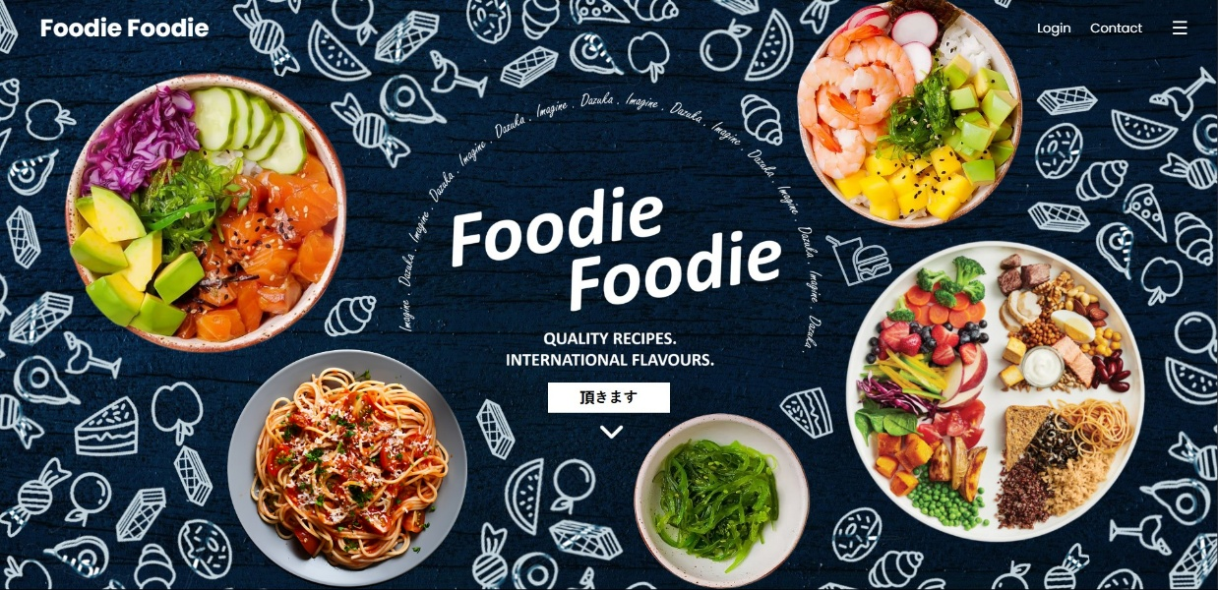

**---- Overview Of the various sections of Home Page :**

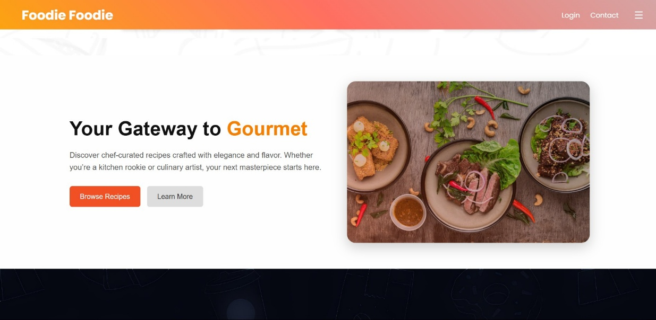

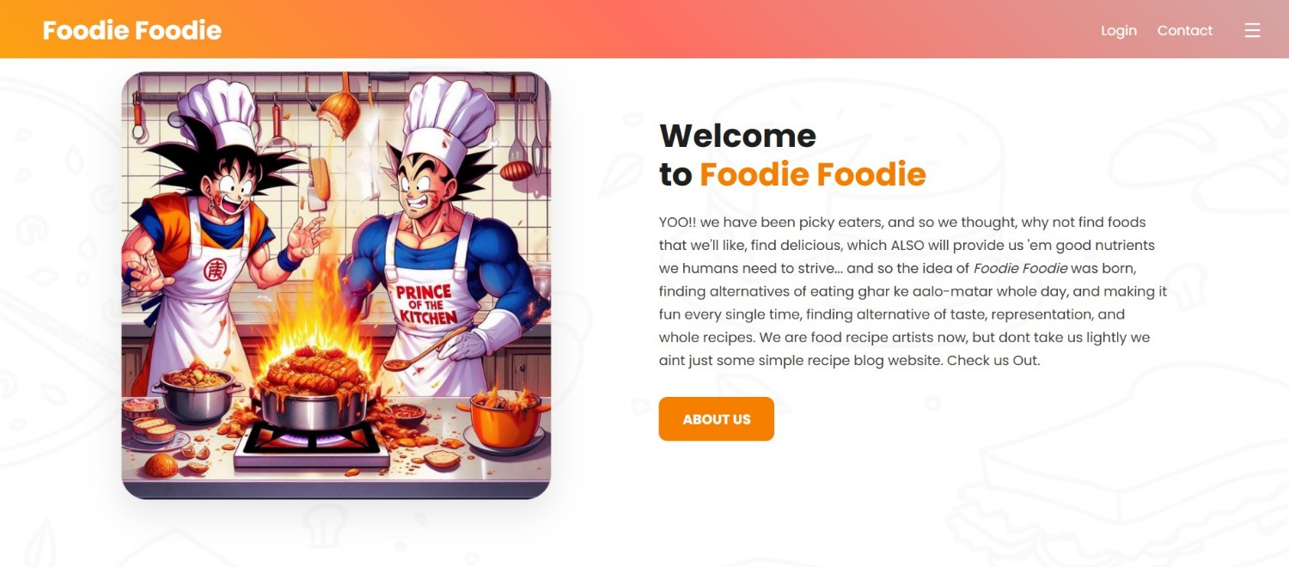

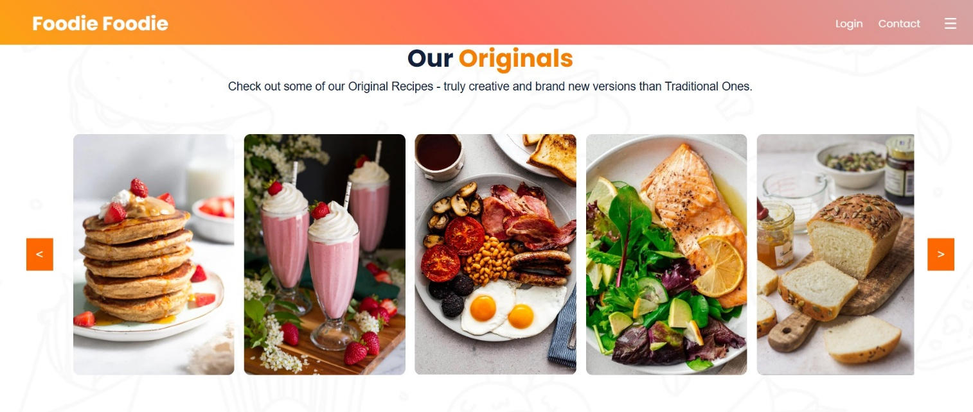

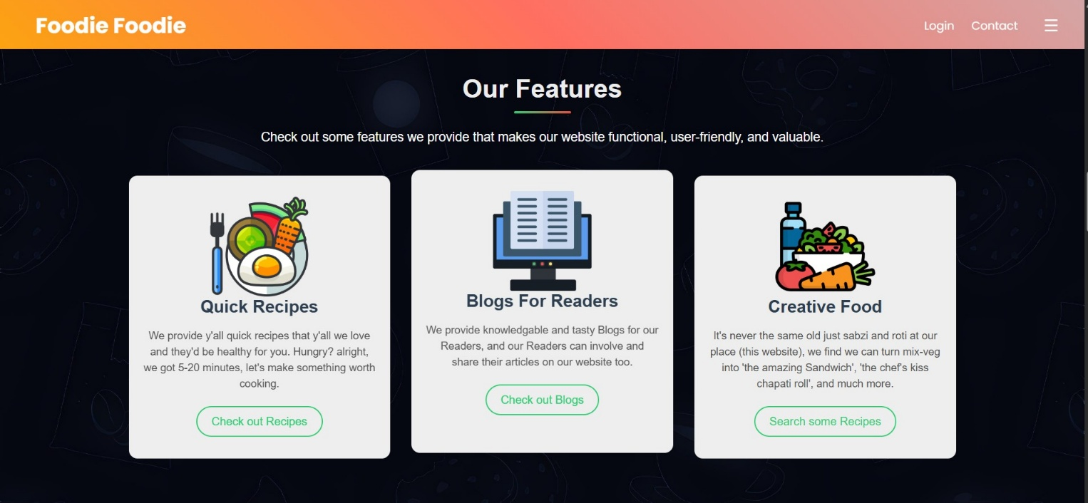

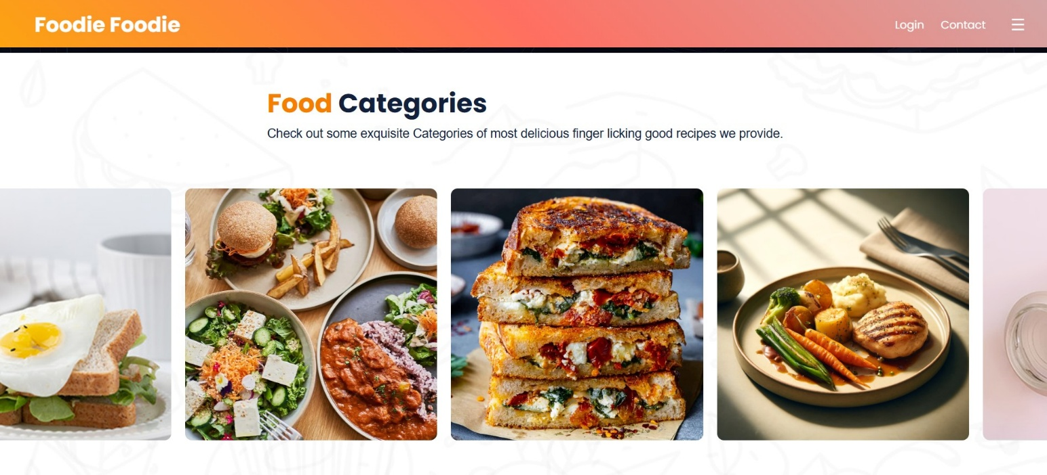

**🔹 Recipe Page**

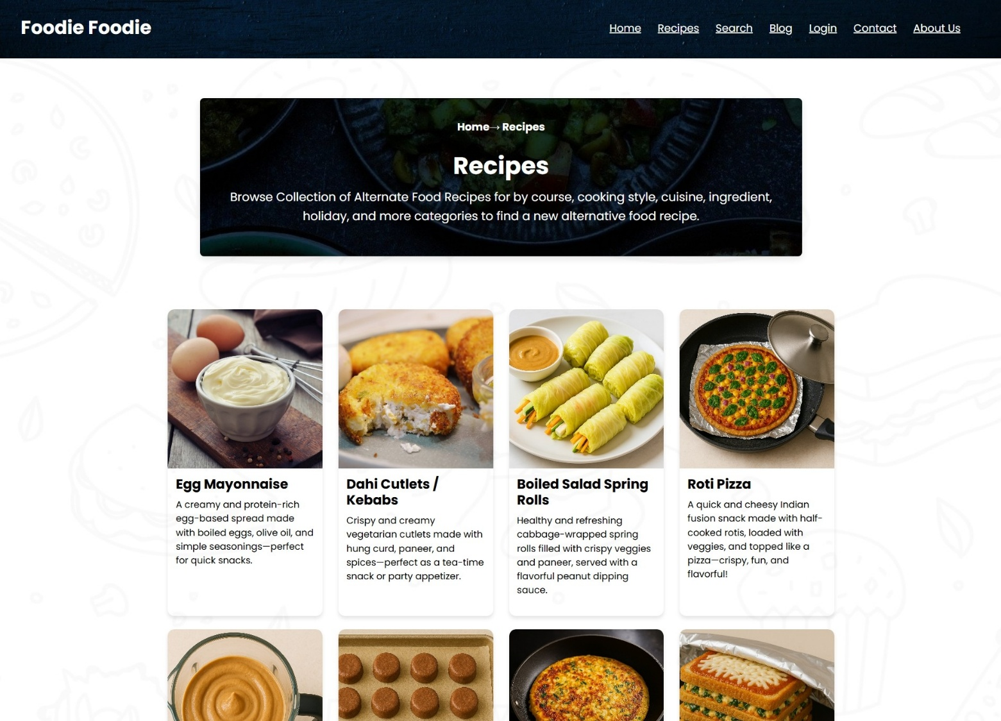

**----Recipe View page :**

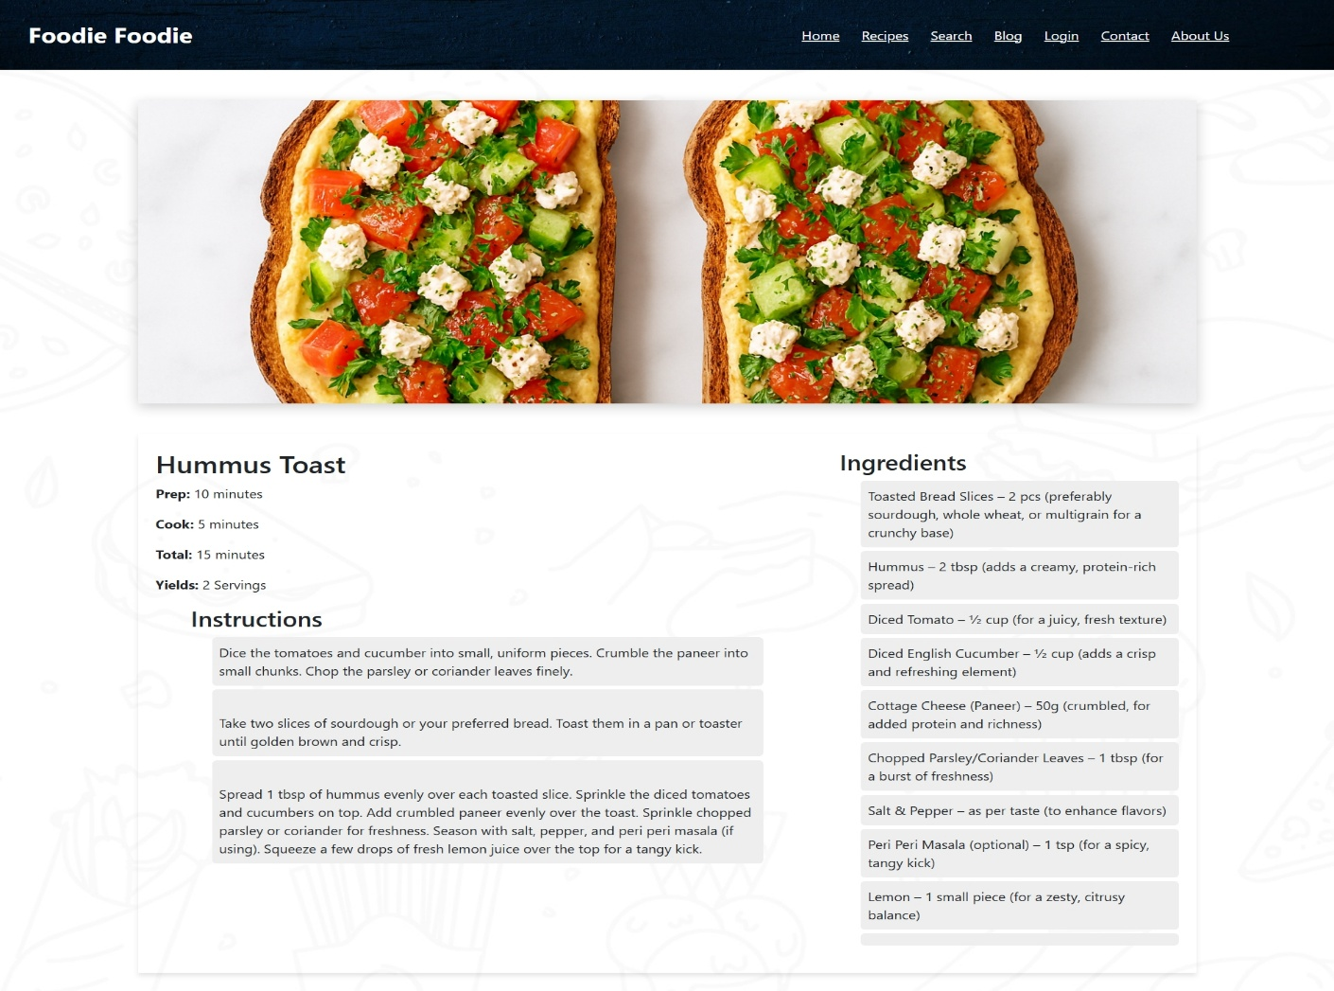

**🔹 Search Page**

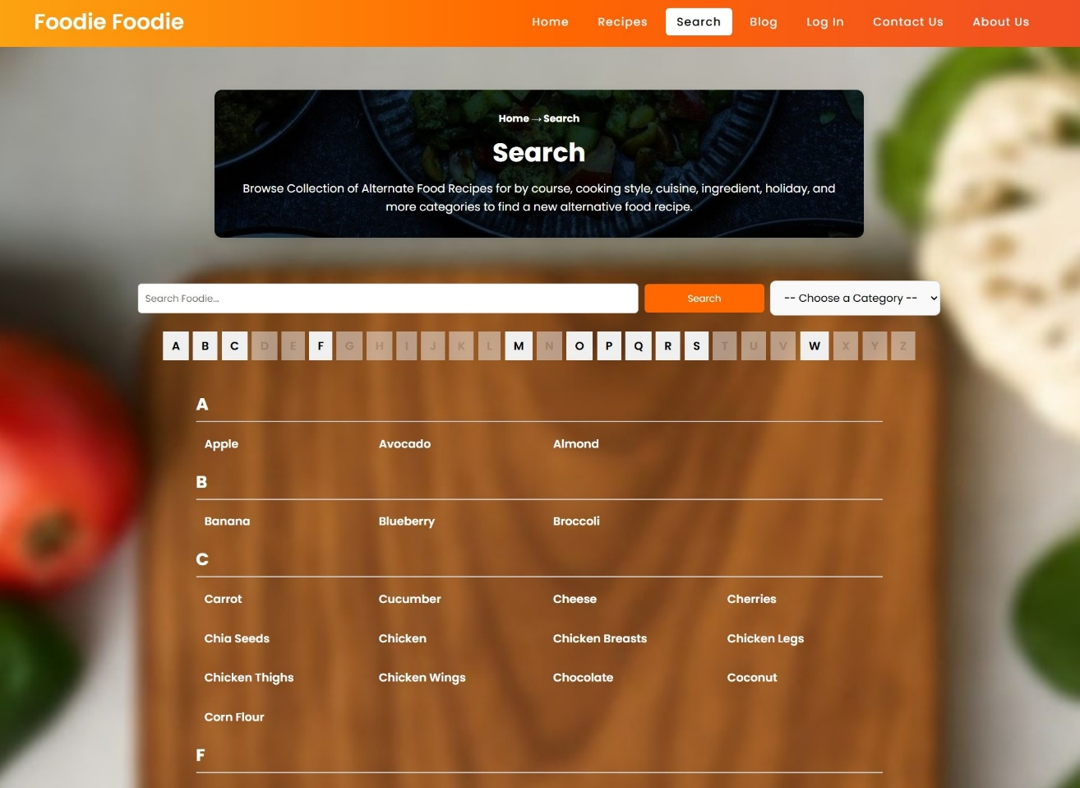

**----Search by Keyword :**

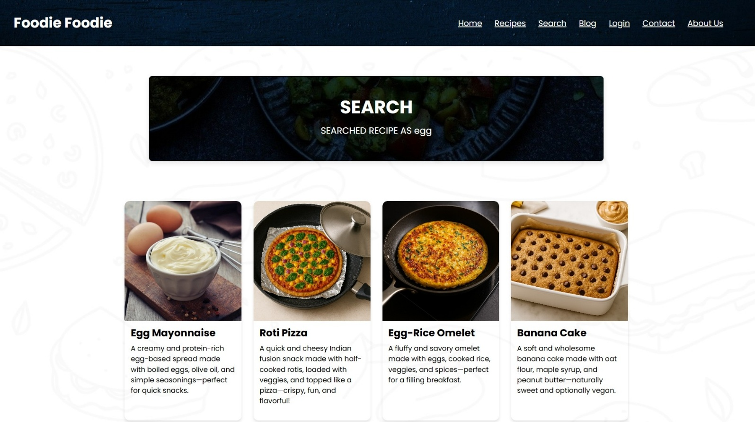

**🔹 Blog Page**

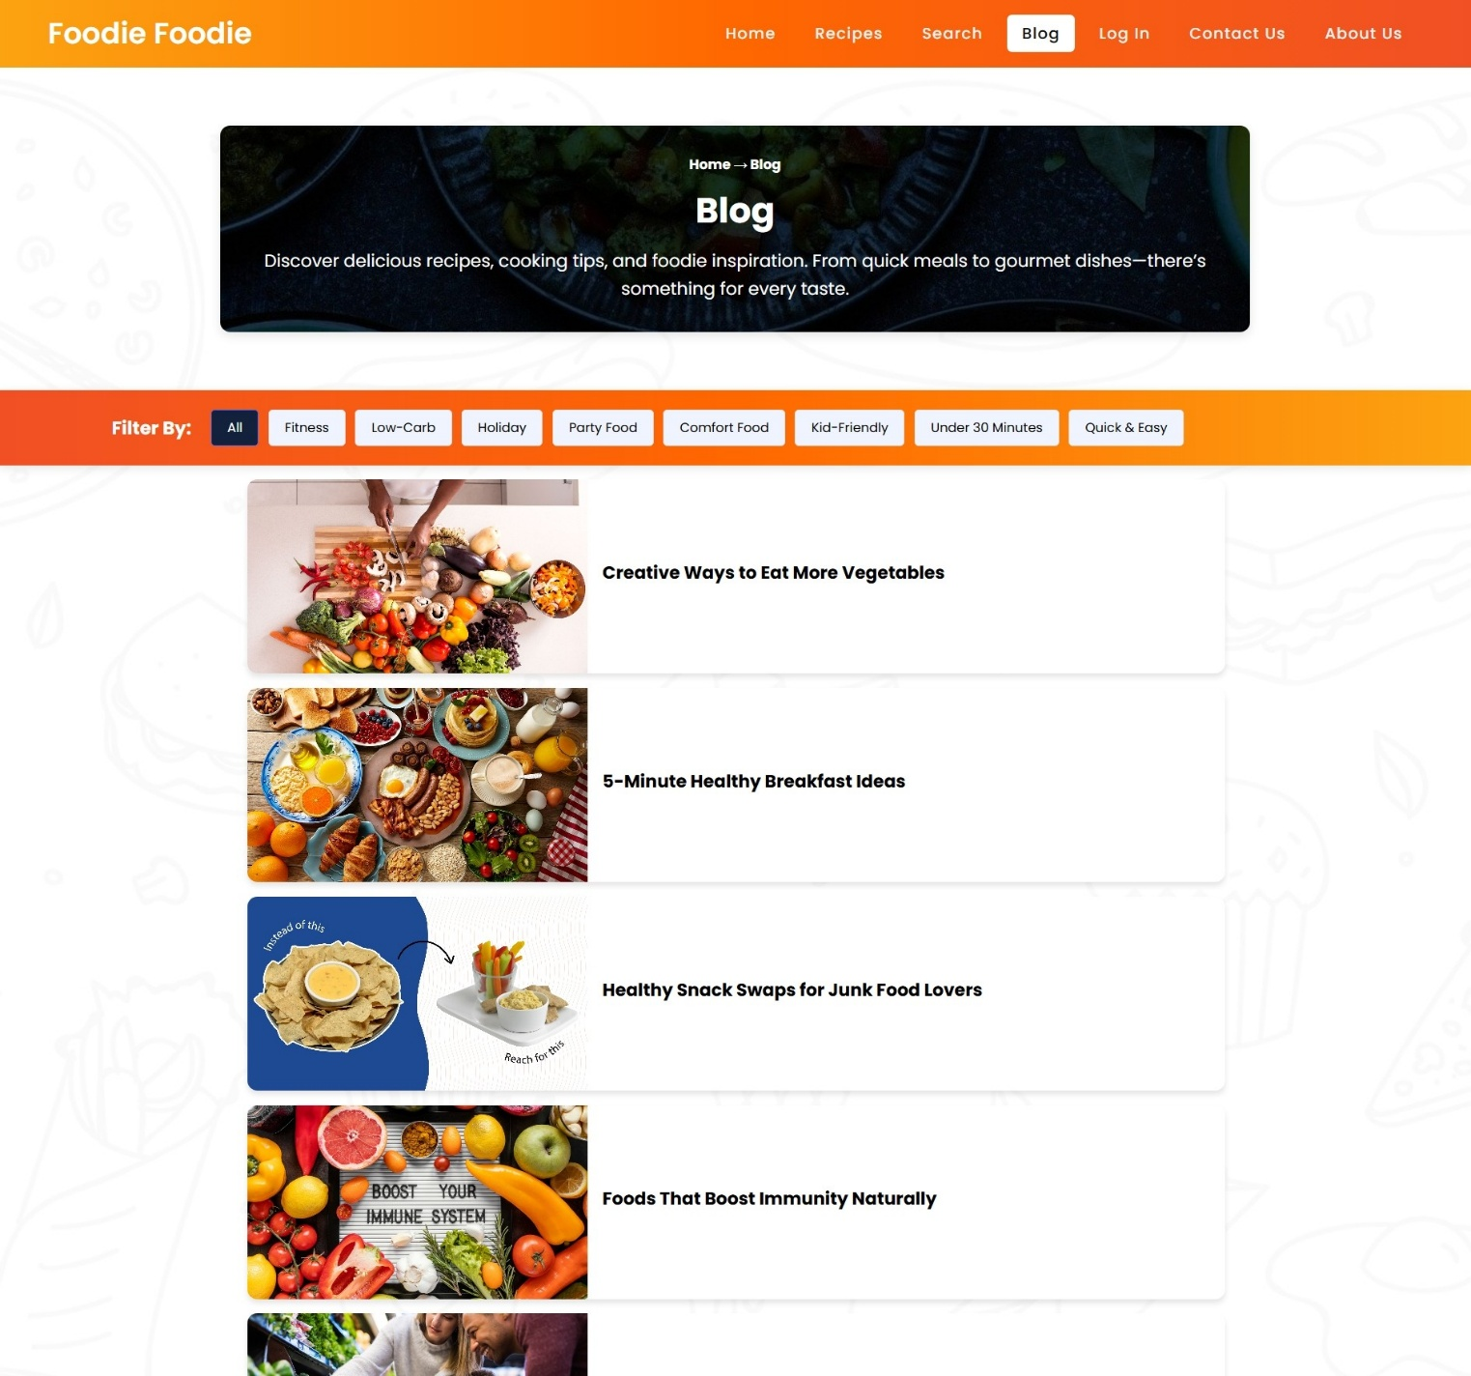

**---- Blog View Page :**

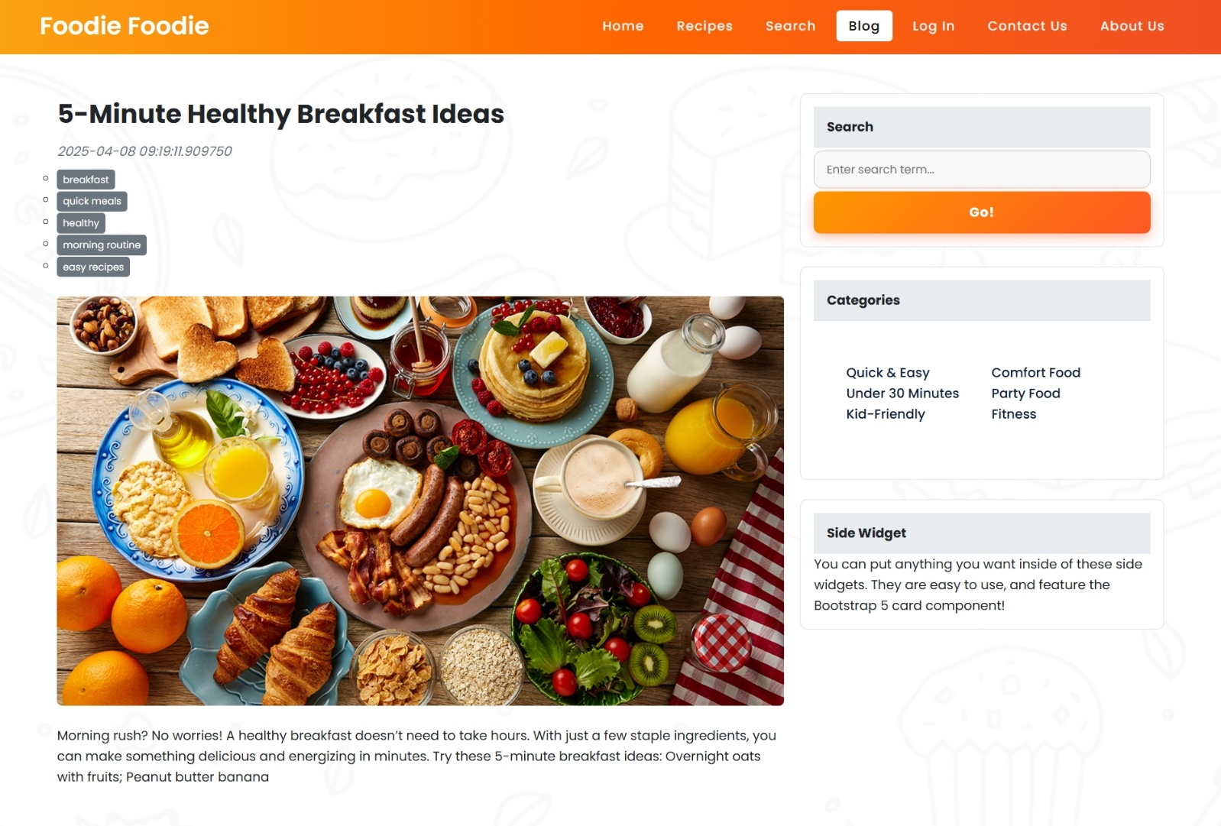

**🔹 User/Admin Authentication**

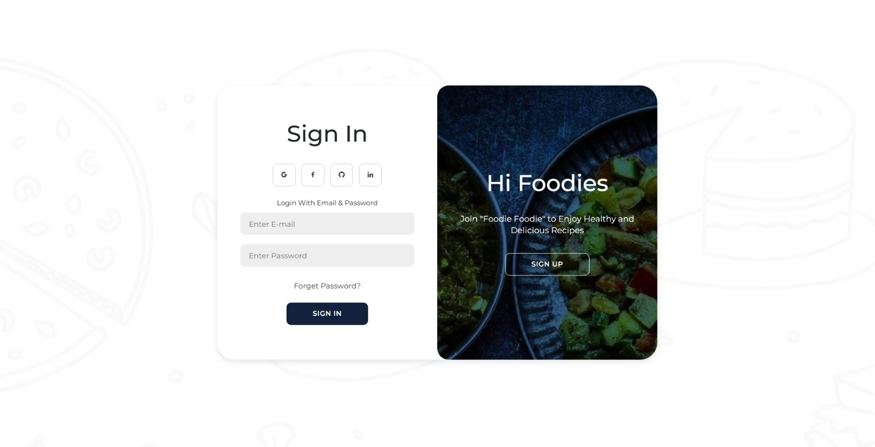

**🔹 Admin Panel**

**---- CRUD operations on Registered Users :**

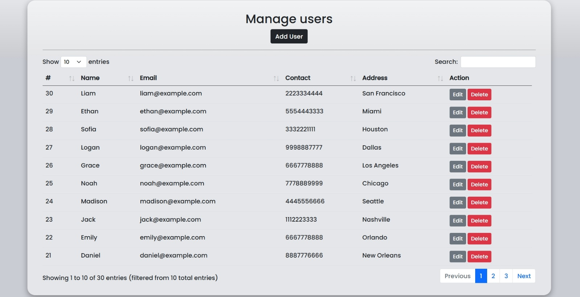

**---- Authority of Admin on Request of a Post by User :**

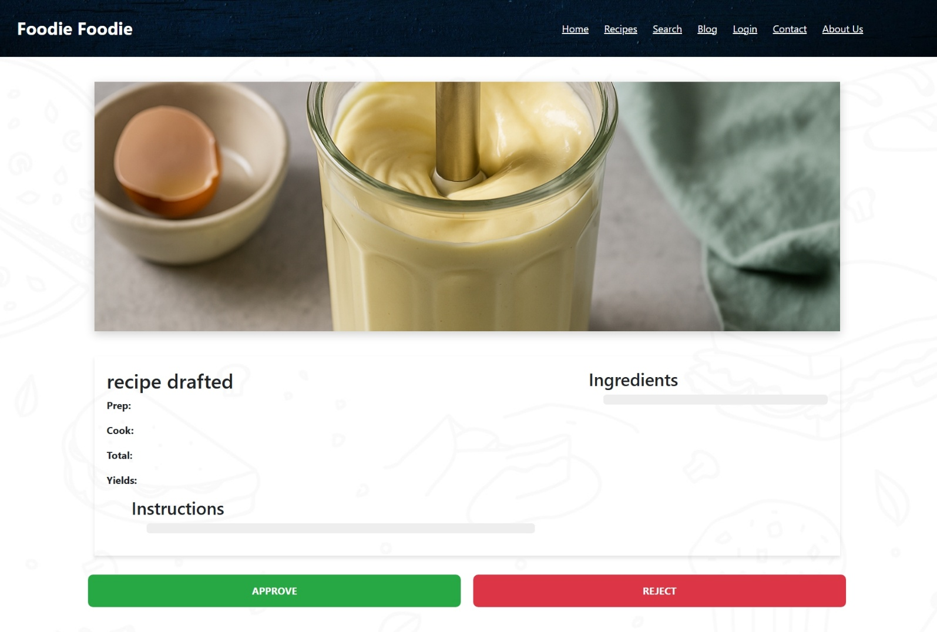

**---- Deleting a Post**

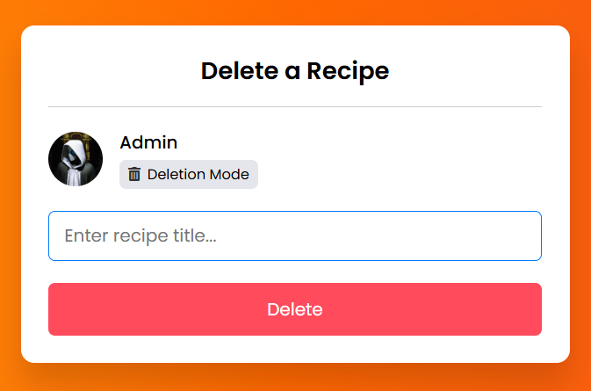

**🔹 User panel**

**---- Users Can raise a request of post in recipe column :**

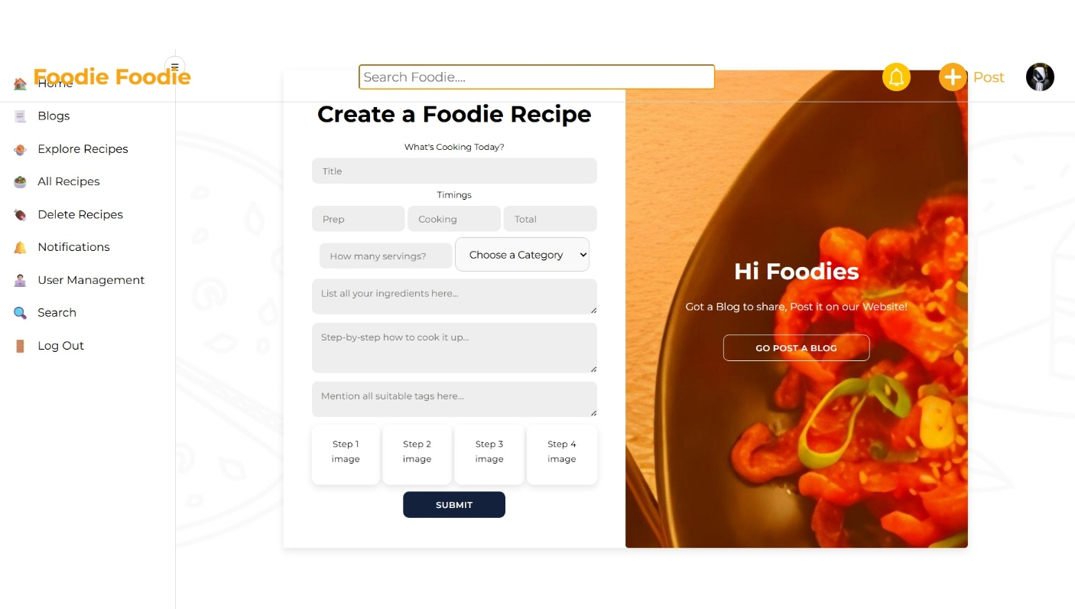

**🔹 Database Tables**

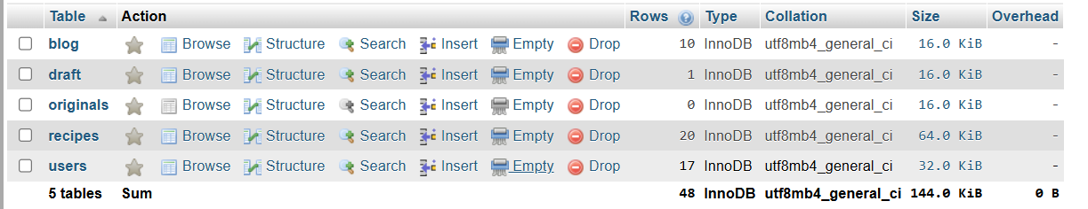

**🧩 Features Summary**

| **Feature** | **Description** |
| --- | --- |
| 🧑‍🍳 Recipe Sharing | Users can submit their own recipes |
| 📚 Blog Management | Admins can upload and moderate food blogs |
| 🔐 Authentication | Secure login for users and admins |
| 📂 Content Moderation | Admin control over content through dashboard |
| 📱 Responsive Design | Fully responsive using Bootstrap |
| 🔍 Search Function | Find recipes or blogs using keywords |